**Turing Machine Intro and Basics**

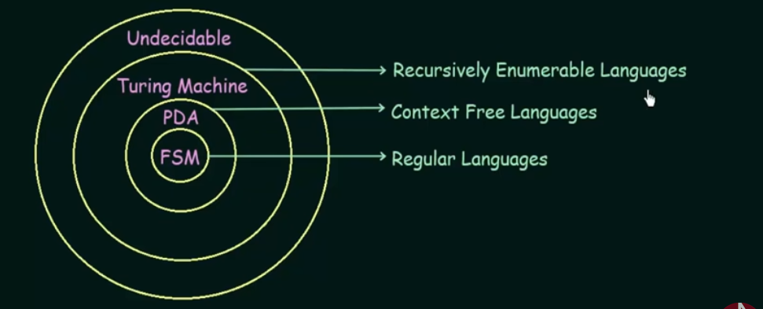

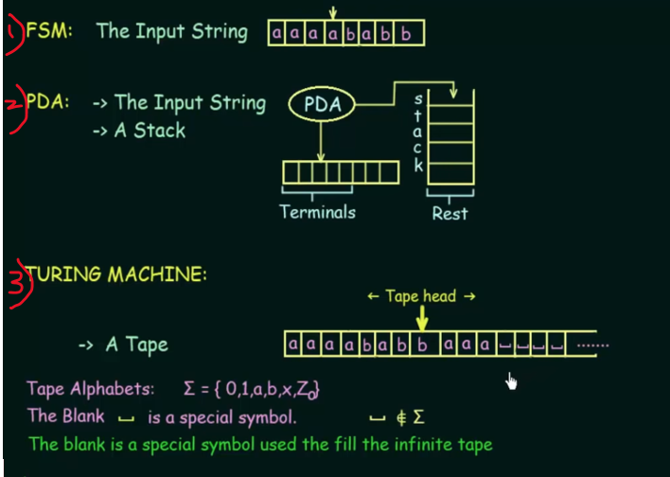

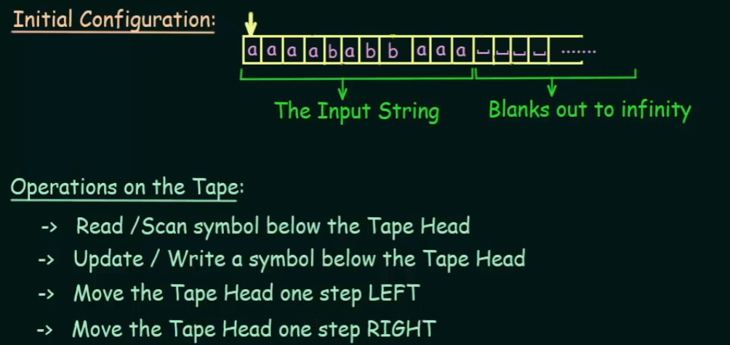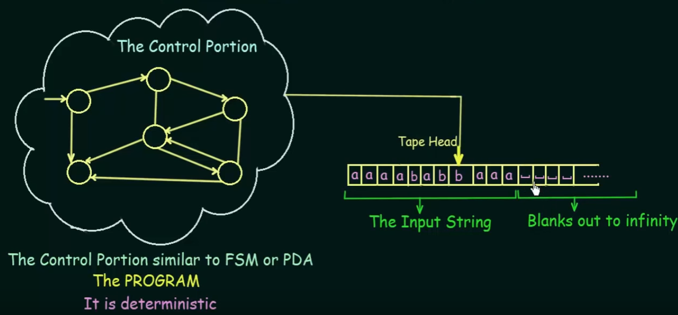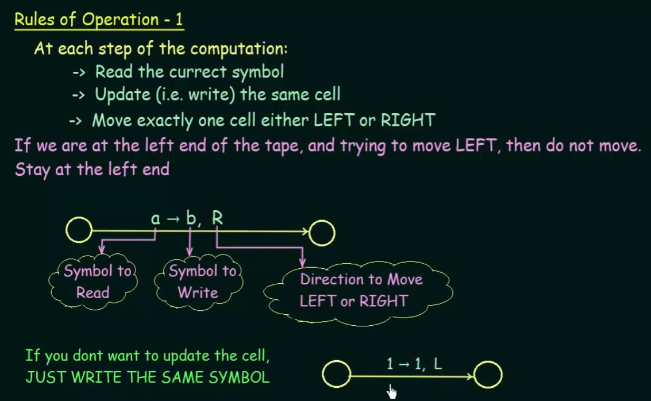

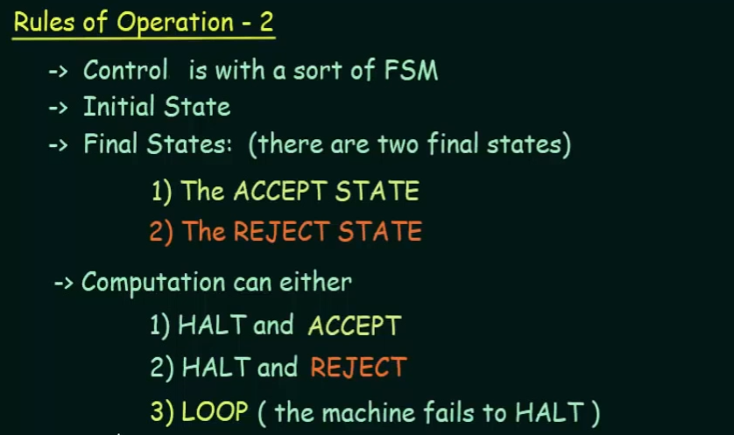

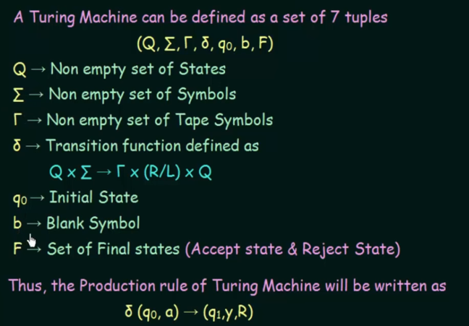

Read the input symbol **a** and write into the tape as **Y** and move to the **right.**

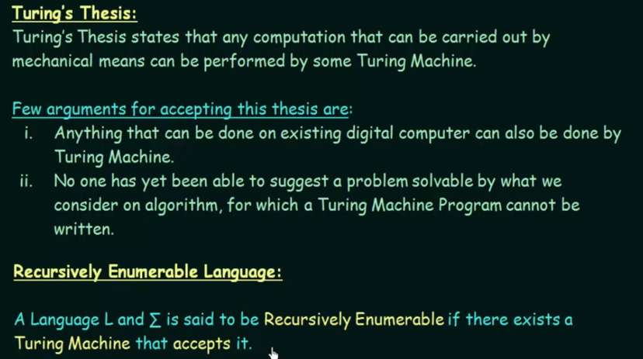

If I have a problem and I designed an algorithm to solve that particular problem, then definitely an Turing machine can also be designed to solve that problem.

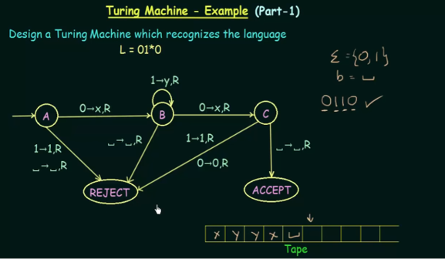

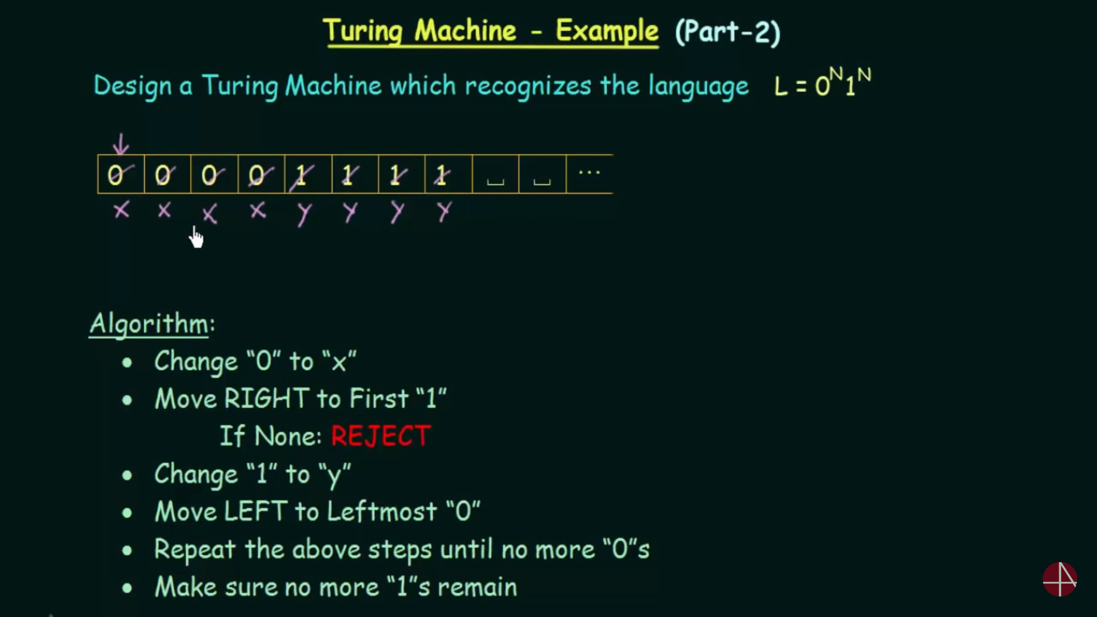  
found 1 extra 0 (i.e 5th 0, change to x and search for 1. If that 1 is not present then reject. There-fore **n(0)!=n(1)**

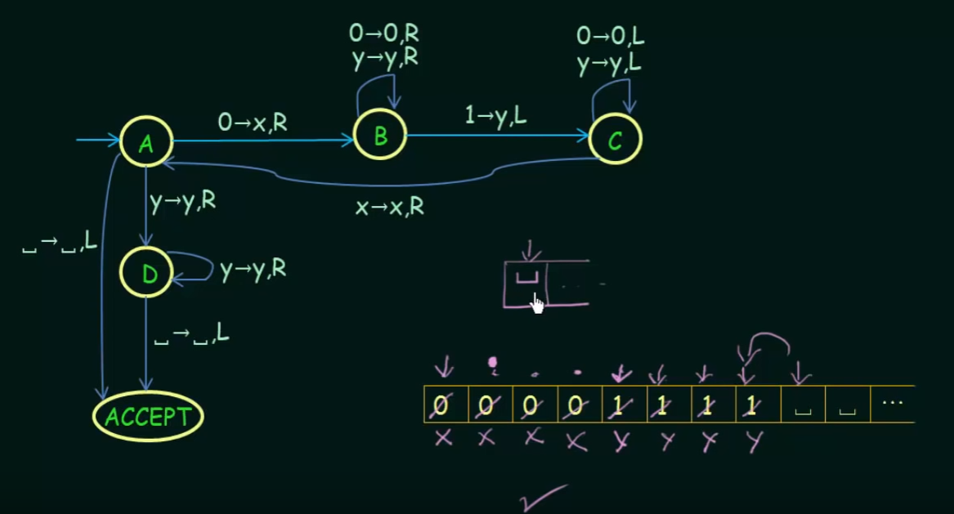

Hint:   
After replacing all the strings(i.e 1 and 0) with x’s and y’s. Simply pass the states with x’s and y’s, if all the strings are exactly replaced by x and y, then your turing machine is correct for the given condition.

Design a Turing Machine that accepts the   
L={a*}  
L = {a^+}  
L = {a^n b^n | n>=1 }

**Question  
L = {a^n b^n c^n | n>=1 }**

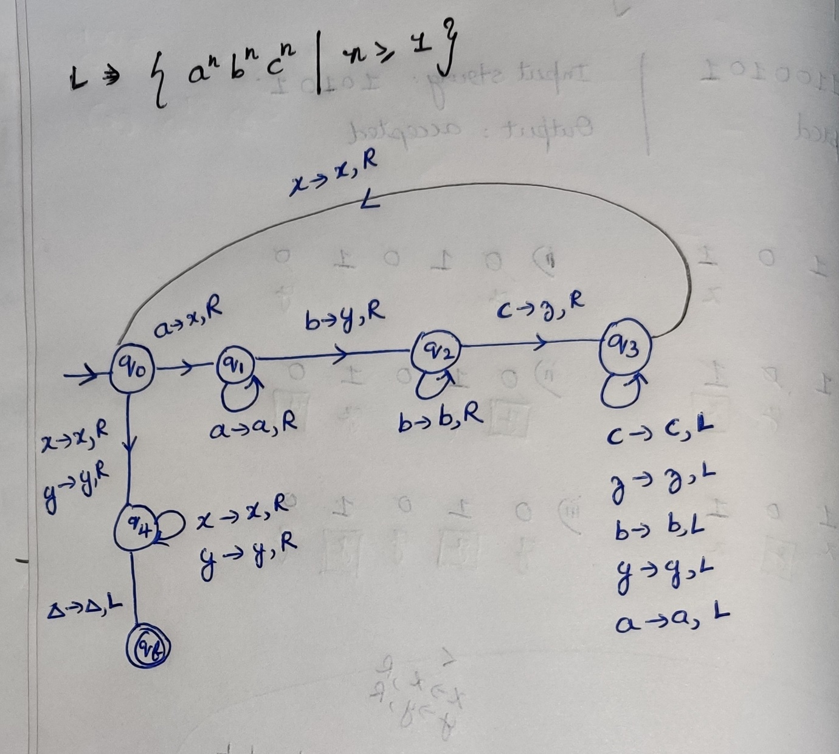

**Question  
L = { ww^r | w belongs (0,1) }**  
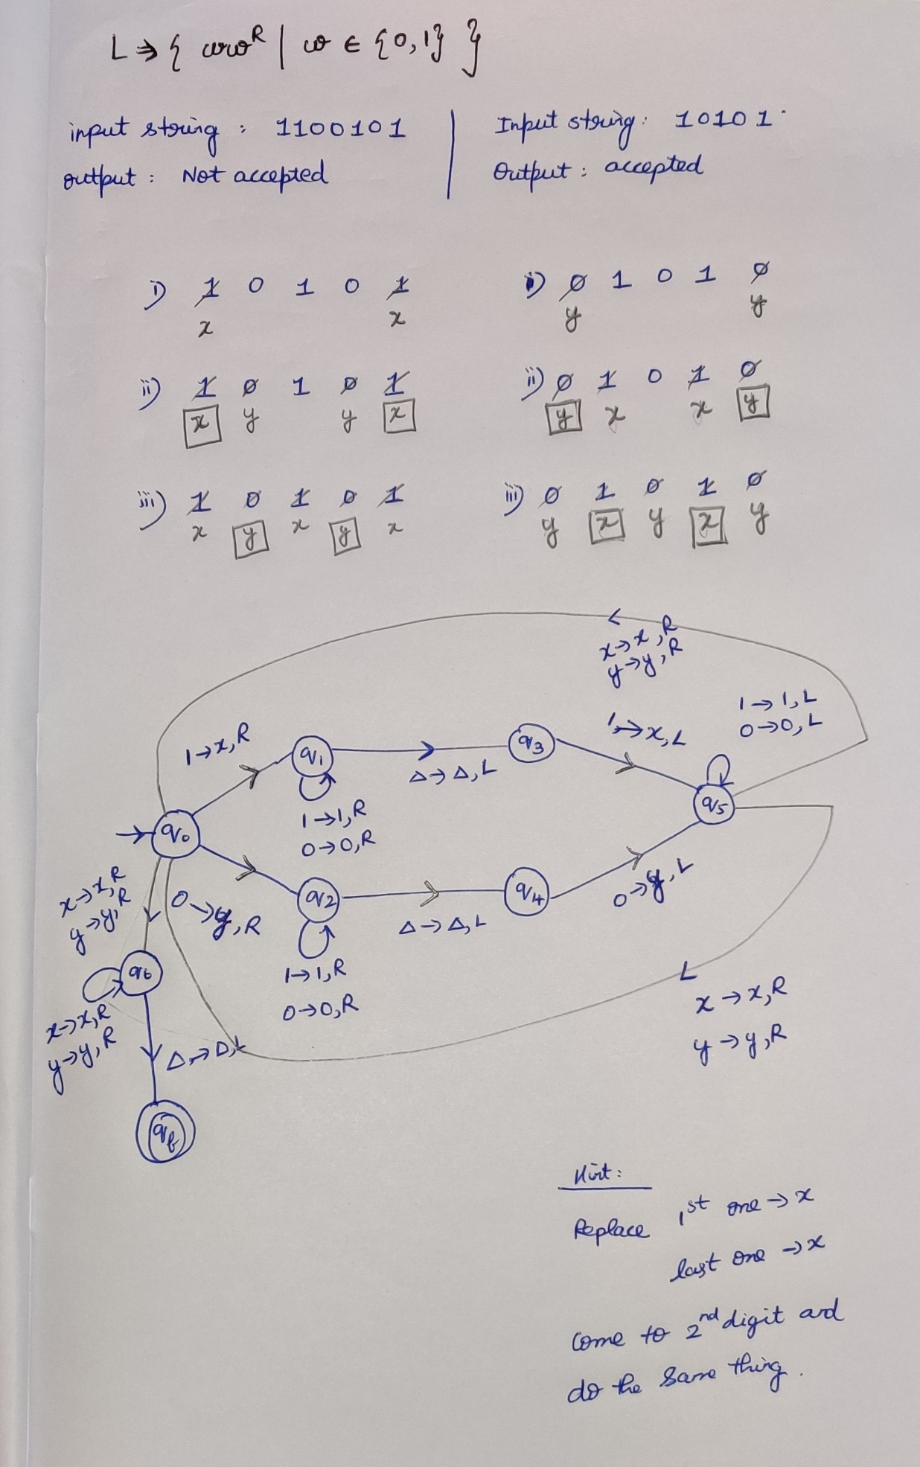

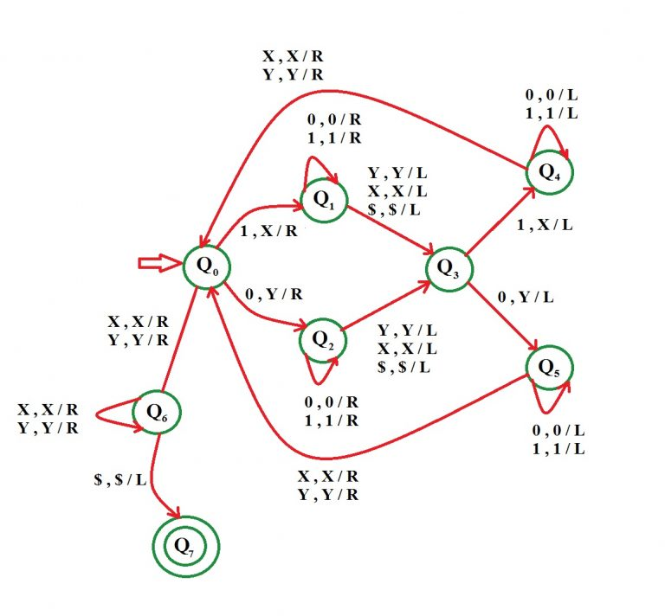

**Question**L = { n(a)=n(b) | w belongs (0,1) }

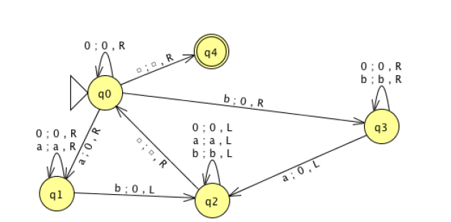

**Question**L = { a^n b^m a^(n+m)| n,m>=1 }  
<https://www.geeksforgeeks.org/construct-turing-machine-l-bm-anm-nm%e2%89%a51/?ref=rp>

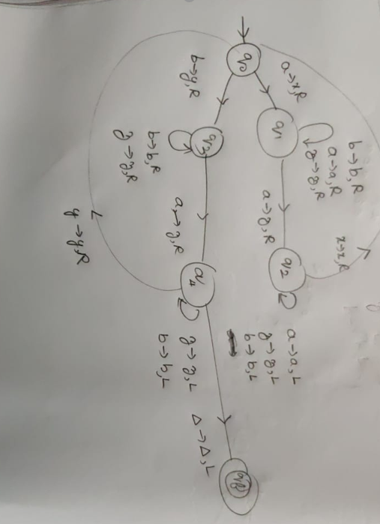

**Question  
L = { 0^2n 1^n | n>=0 }**

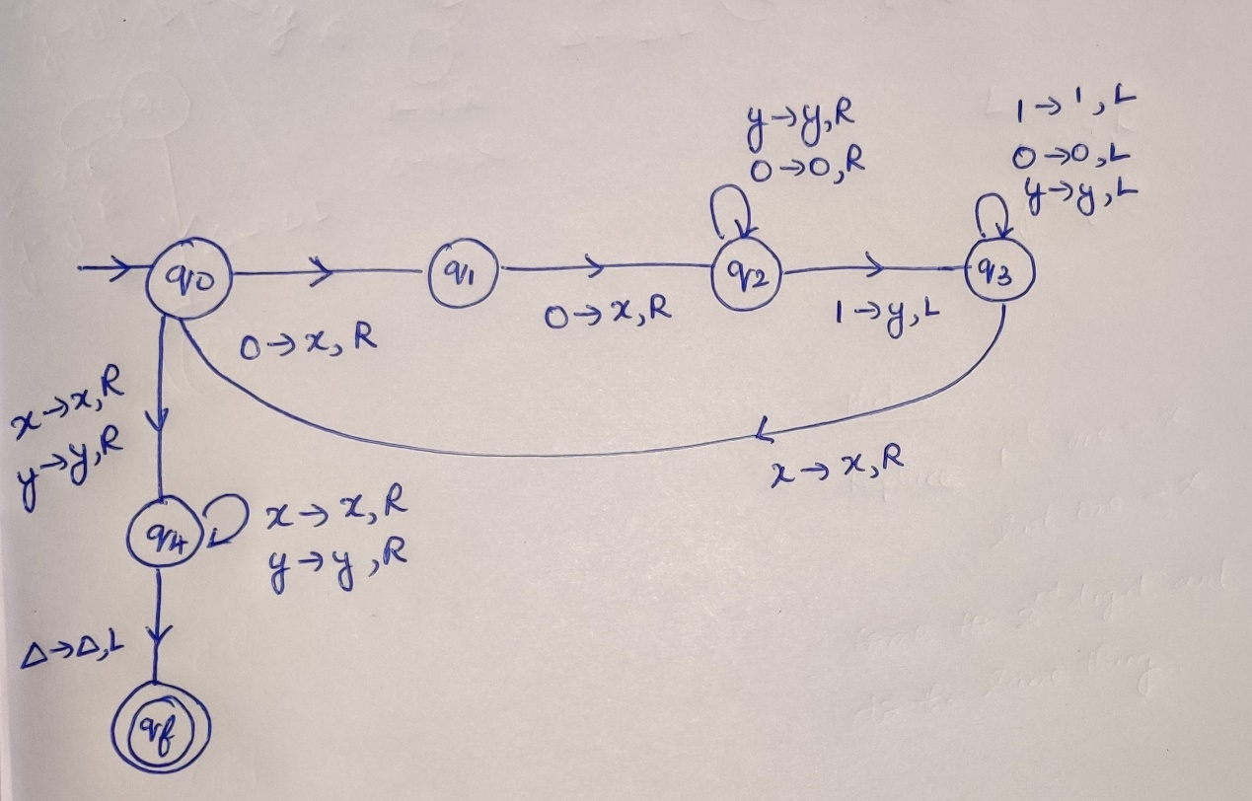  
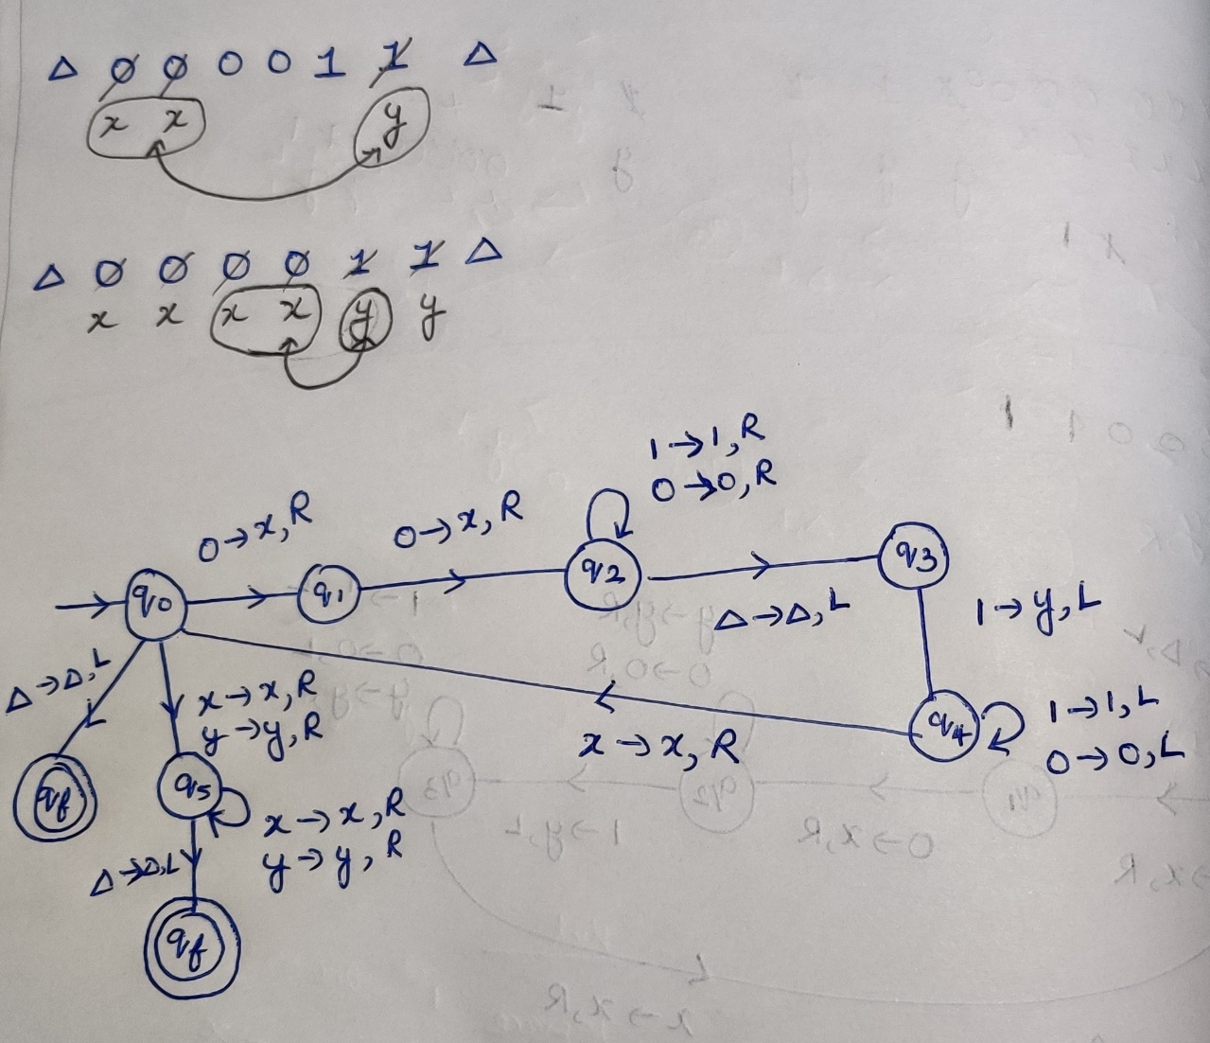

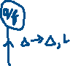

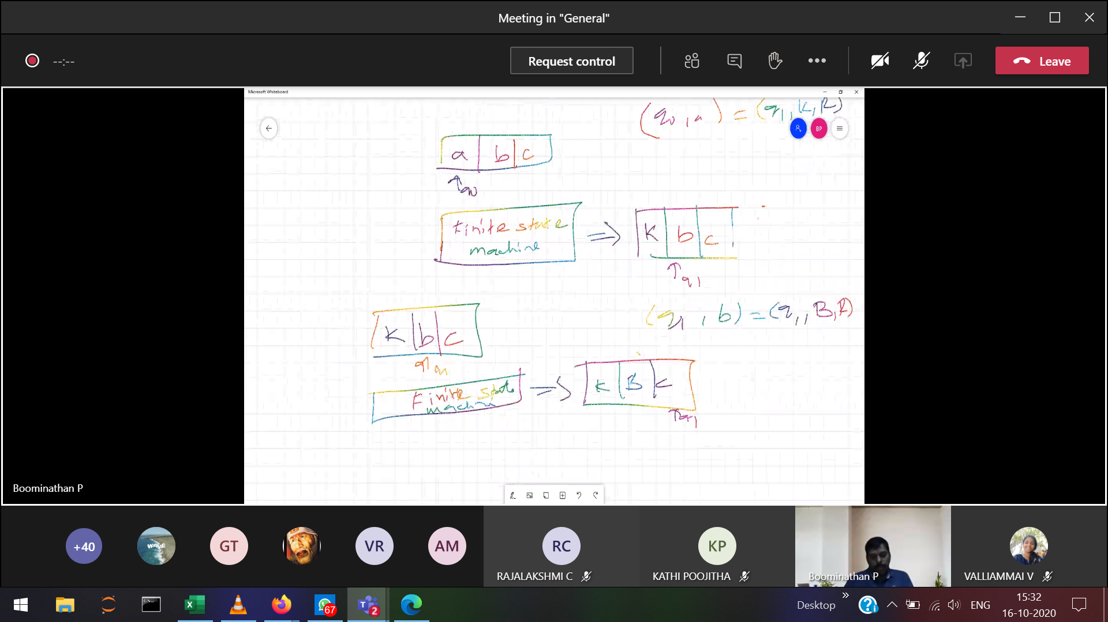



Instantaneous Description